UML Profile and Naming Conventions

1. UML Profile

* Class
* Association
  + Name
  + Ordering
* Composition
  + Name
  + Cardinalities (source and target)
  + Ordering
* Generalization
* Attributes
  + Name
  + Cardinality
  + Datatype
* List of primitive datatypes
  + Mappings to RDF datatypes
  1. Open issues
* Ordering
  + Is this important? Can we rely on the ordering in the XML for ordering of content declarations?
* Unions
  + Do we need unions? Maybe use abstract classes?
* Abstract classes
  + Abstract classes needed?
* Can we refine with extensions?
* UML constraints
  + Do we need UML constraints to allow for choices?

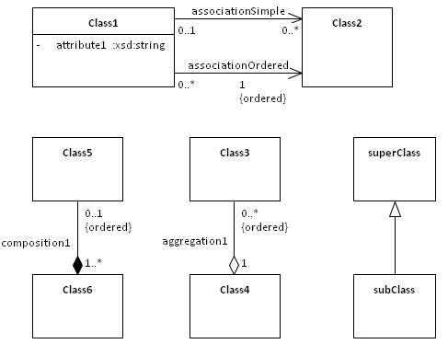

**Fig. .** UML Profile

1. Motivation to use UML profiles

* Check model on usage of restricted set of UML constructs
* Solutions
  + Other modelers check it manually.
    - Advantage: It could be a general review and not just a check on the used UML constructs
    - Disadvantage: time-consuming
  + Automatic technical check
    - Usage of UML profile mechanism in Enterprise Architect as a restricted requirement for creating the model
    - Advantage: immediate restricted use of selected UML constructs
    - Disadvantage: just technical check, no general review
* Current status of understanding of Enterprise Architect UML profiles
* There is no solution yet
* Enterprise Architect help file has entries on profile and toolbox which describes ways to create UML profiles and toolbox profiles
* Process of exploring this is put on the parking lot. It is too time-consuming currently
* Expertise of an additional EA expert should be used for this purpose
* EA examples to create UML profiles describe adding stereotypes, but we didn’t find examples to restrict allowed UML constructs

1. Naming Conventions
   1. Packages

?

* 1. Classes
* Start with upper-case character
* CamelCase
* No blanks
  1. Associations
* Start with lower-case character
* CamelCase
* No blanks
* <qualifier><target class name> (e.g. ‘DefiningCategory’ pointing to target class 'Category') [<qualifier> specifies ]
  1. Compositions
* Start with lower-case character
* CamelCase
* No blanks
  1. Attributes
* Start with lower-case character
* CamelCase
* No blanks

1. Modeling Rules
   1. Target cardinality of an association

If the target cardinality of an association is 1..1 or 1..n, then the direction of the relationship is wrong

1. Organization of Packages

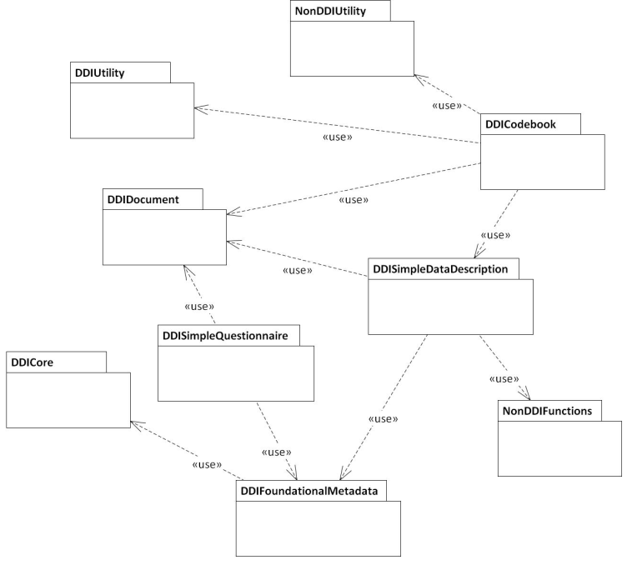

**Fig.** 2**.** Organization of Packages

* Functional modules extend foundational
* Name of package is URI
* Root element is just a box in the model extending the ur-document
* An external universal doctype which can hold anything, a trivial abstract ur-document

1. Primitive Types in the Core

A set of primitive types to be included in Core.

|  |  |
| --- | --- |
| **Class** | **Namespace** |
|  |  |
| CodeValueType | DDI |
| HistoricalDateType | DDI |
| IDType | DDI |
| InternetEmailType | DDI |
| InternationalCodeValueType | DDI |
| InternationalStringType | XML |
| LabelType | DDI |
| NameType | DDI |
| NumberRangeValueType | DDI |
| RangeValueType | DDI |
| StringType | DDI |
| StructuredStringType | XHTML |
| URNType | DDI |
| URLType | DDI |
| UserIDType | DDI |
| BaseDateType | DDI |
| BaseIDType | DDI |
| CategoryRelationCodeType | DDI |
| DDIAgencyType | DDI |
| DDIIDType | DDI |
| DDIURNType | DDI |
| LatitudeType | DDI |
| LongitudeType | DDI |

1. Utility Types

|  |  |
| --- | --- |
| **Class** | **Namespace** |
|  |  |
| CountryType | DDI |
| CountryCodeType | DDI |
| GeographicDescriptionCodeType | DDI |
| ISO2CountryCodeType | DDI |
| ISO3CountryCodeType | DDI |
| ISOCountryCodeType | DDI |
| ISONCountryCodeType | DDI |
| LanguageList | DDI |
| PointFormatType | DDI |
| RecommendedCountryCodeClassCodeType | DDI |
| ShapeCodedType | DDI |
| TypeOfObjectType | DDI |